Peace Lutheran ministries
December 24, 2025
9:00 am & 4:00 pm
WELCOME!
We love that you are here today! We are glad that you have joined us today to celebrate the birth of the Christ child. Our service is printed for you in its entirety in this worship folder.

Restrooms are located in the hallway to the right as you exit the worship space, as well as across the hall as you enter into the school.

Quiet room Parents may use the library in the back of this worship space which still enables you to hear/see the service.

A Connection Card and pen are found in the pocket of the chair in front of you. Time will be provided to fill it out during the service. You may drop it in the wicker basket along the wall after the service.
Today’s Focus
We trust that God will bless you in this service of Scripture lessons and songs. Our focus tonight is the real, true and lasting peace God has given us in the birth of Jesus Christ.

Everyone is looking for peace. Yet the truth is, it remains elusive to our efforts. Lasting peace cannot be found in this world, it must come from beyond it. Tonight we hear the good news of great joy that Peace indeed came to earth in the person of Jesus Christ, born the Savior for all the people. Just as the angels sang that first Christmas night, God has brought peace to His people on earth. Jesus establishes peace between God and humanity, peace that transcends even death, peace that will heal all our wounds and dry all our tears, when He ushers in the new heavens and earth in His endless reign of peace.

Tonight we rejoice that in Jesus, Peace Came to Earth, Peace that will last for all eternity. May God grant us His perfect Peace.
Today tonight tomorrow
Continue to celebrate the Gift of God that is the birth of Christ at our Candlelight service at 9:00 pm tonight (a service conducted by Peace Teenagers) and 9:00 am Christmas morning (a festival service with Holy Communion focusing on the mystery of the Incarnation).

YOU CAN MAKE A ONE-TIME OFFERING ON YOUR PHONE
If you’d like to make a one-time electronic offering to Peace you may use this QR code with your phone. Thank you for your support of Peace’s ministry.

the christmas season
“The Twelve Days of Christmas” run from tonight through the festival of Epiphany. Join us as we continue to “unwrap” the amazing Gift of God in Christ!

Wednesday, December 24: Christmas Eve Candlelight Service 9:00 pm

Thursday, December 25: Christmas Day Service 9:00 am

Sunday, December 28: The First Sunday After Christmas 8:00 & 10:30 am
(NO Sunday School)

Monday, December 29: The First Sunday After Christmas 6:30 pm

Sunday, January 4: The Epiphany of our Lord 8:00 & 10:30 am

Monday, January 5: The Epiphany of our Lord 6:30 pm

Serving In Worship

Presider Rev. Shaun Arndt
Keyboard Mrs. Cathy Gresens
Instrumentalists Tim Gustafson, Mina Matson, Gresens Girls
Peace Came to Earth

OPENING HYMN A Great and Mighty Wonder | CW 349
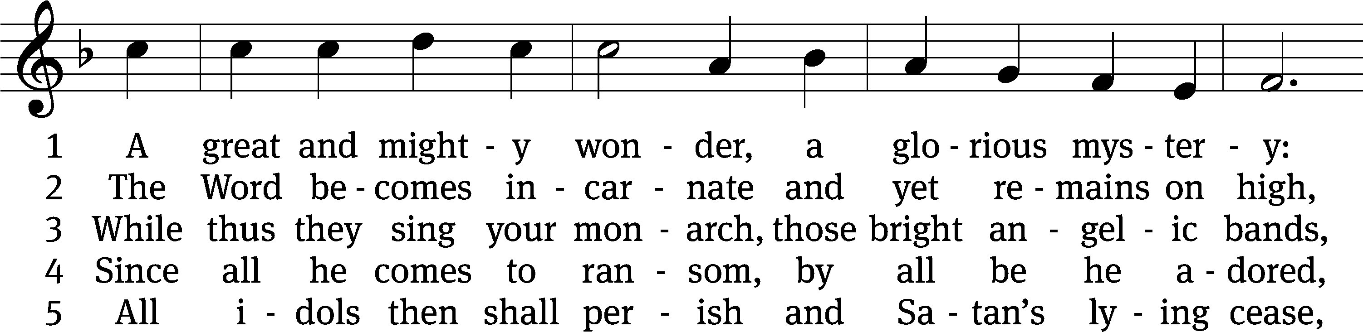
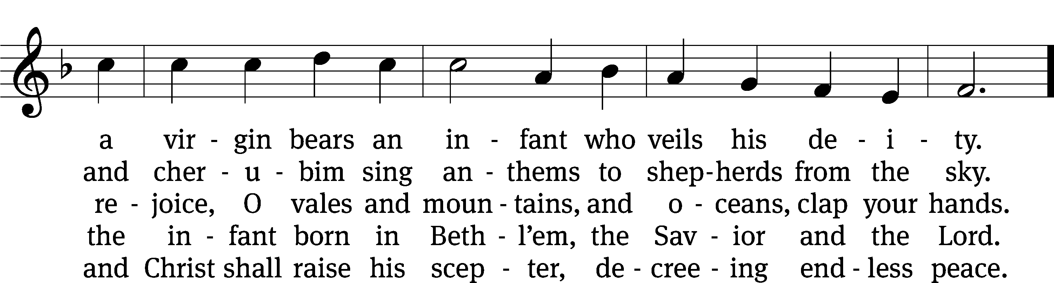
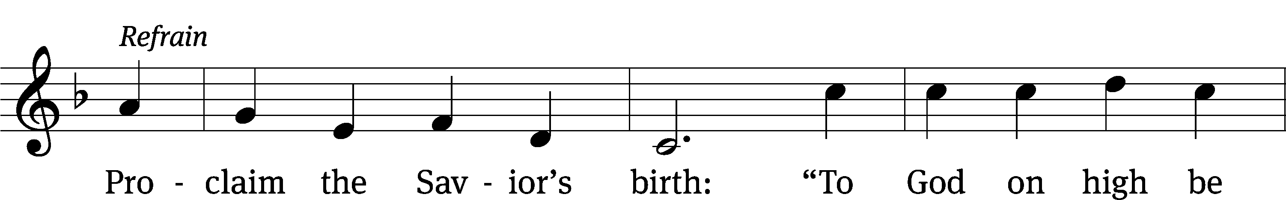
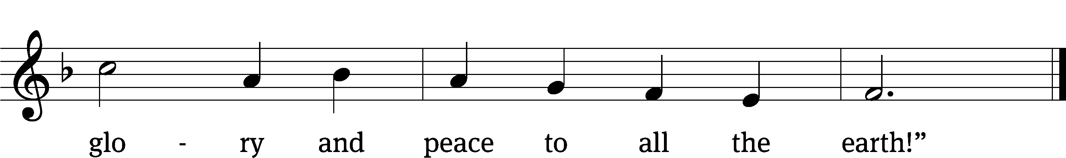
Text: Germanus, c. 634–c. 734; tr. John Mason Neale, 1818–1866, alt.
Tune: Alte Catholische Geistliche Kirchengeseng, Köln, 1599
Text and tune: Public domain

Please stand

Invocation
M: In the name of the Father and of the Son and of the Holy Spirit.
C: Amen.

CONFESSION AND ABSOLUTION
M: On this holy night of festive joy, we remember our deep spiritual need, which compelled the Father to send his Son. Because of our sins, we need the Savior, the One promised by God. We are sinful flesh born of sinful flesh. Out of our sinful hearts come evil thoughts, words and actions.
C: I confess my personal sins against you, the holy God. I have sinned in what I have done and in what I have left undone. I deserve the full force of your wrath. I am deeply sorry for my sins.

M: Do not be afraid. I bring you good news of great joy for all the people. “Today in the town of David a Savior was born for you.” The little Lord Jesus, asleep on the hay, always did what is right and never left anything undone. He bore the full force of God’s wrath on the cross instead of us. He shed his holy blood to cover all your sins. He rose from the dead because God has declared you “not guilty” of sin. You have peace with God through your Savior, Jesus. As a called servant of Christ and by his authority, I forgive you all your sins in the name of the Father and of the Son and of the Holy Spirit.
C: Amen.

HYMN RESPONSE What Child Is This | CW 344
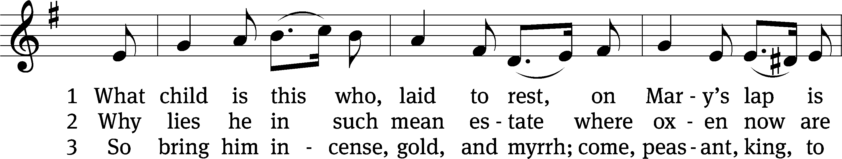
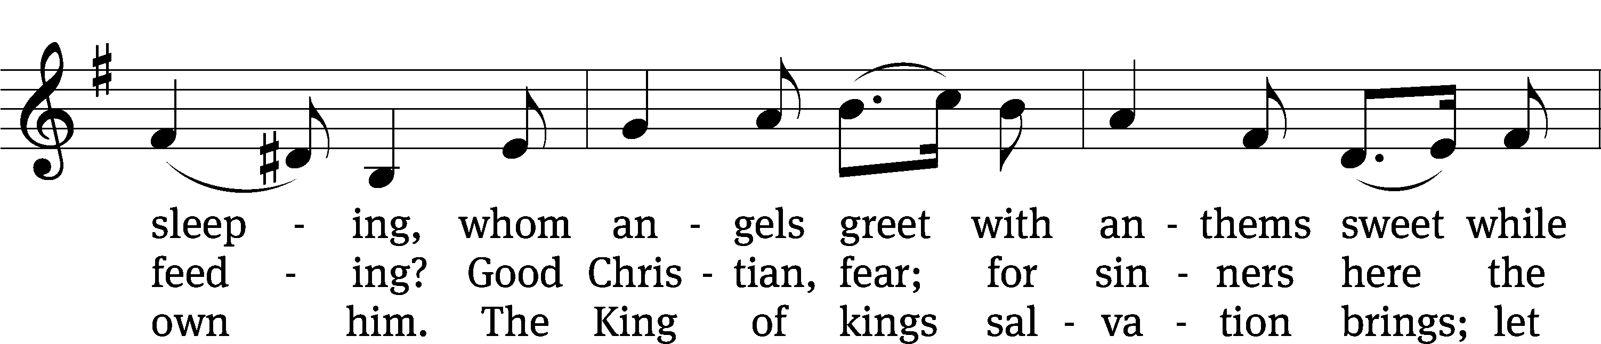
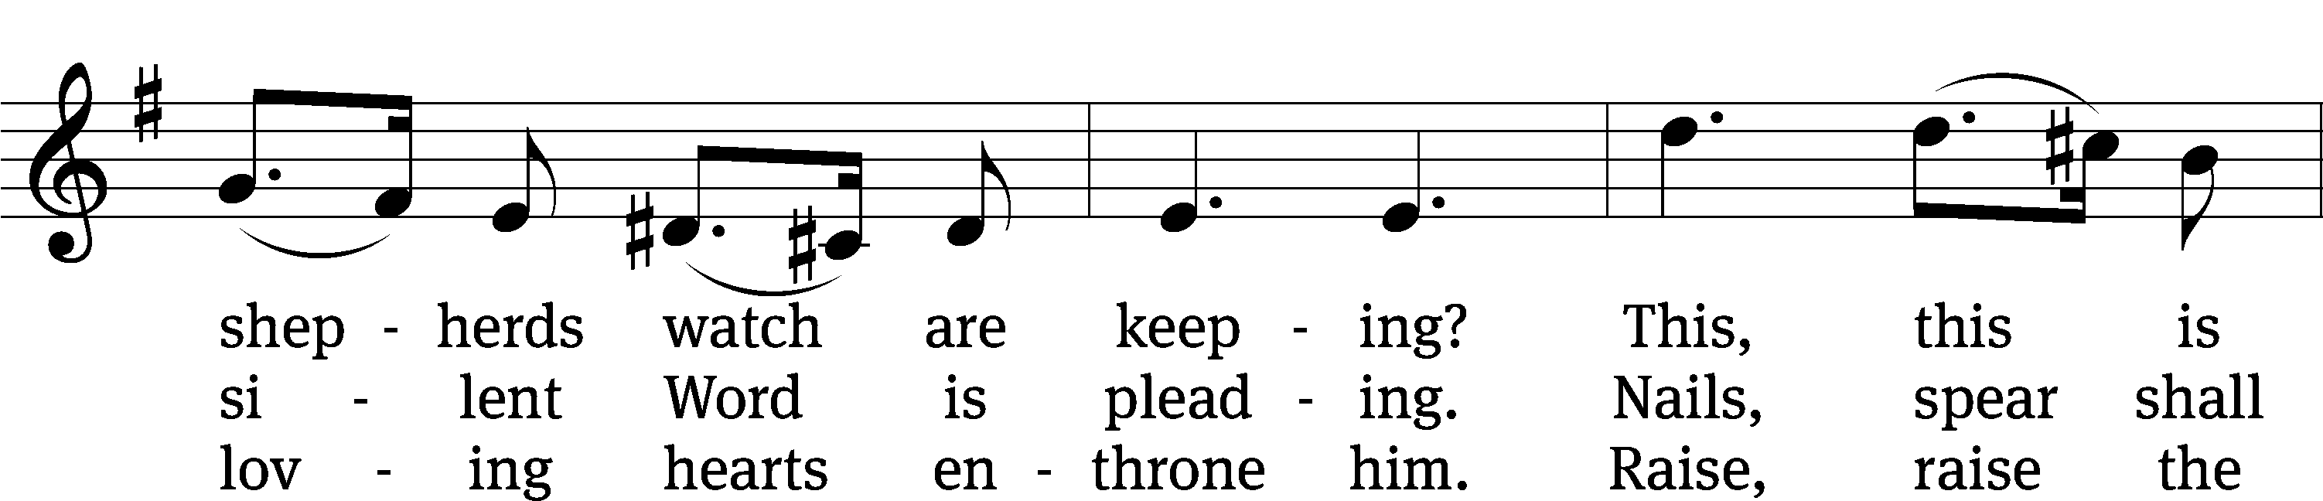
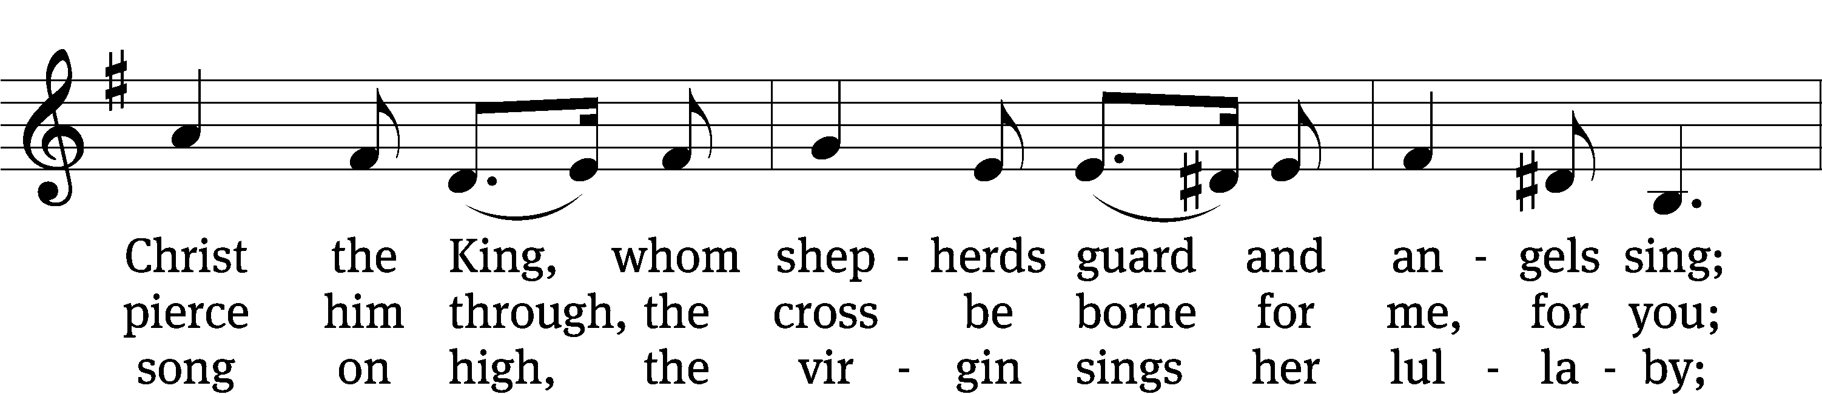
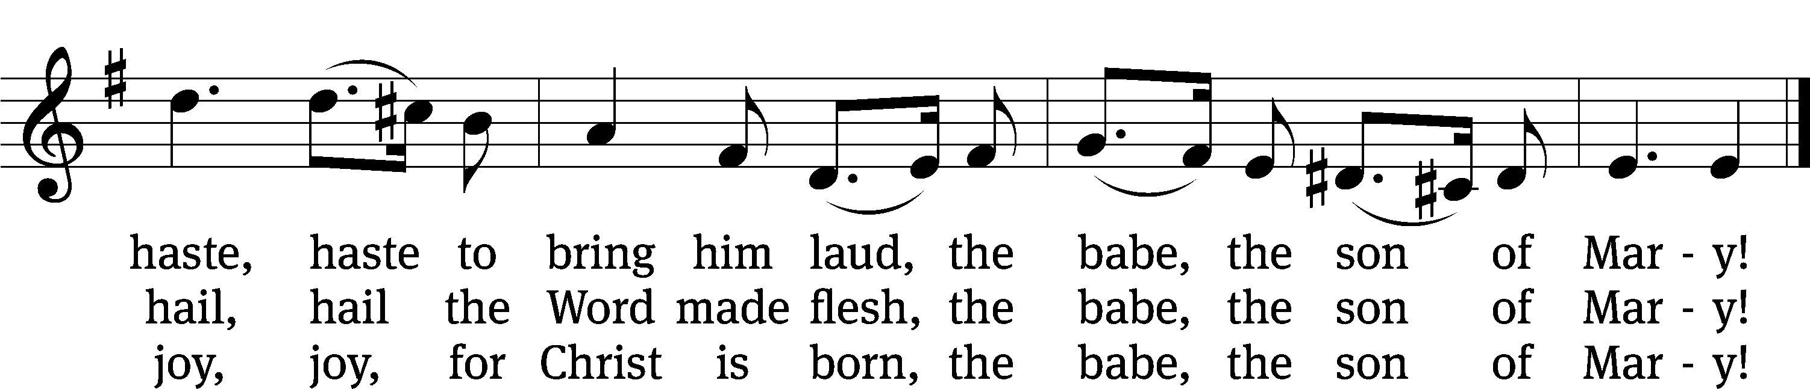
Text: William C. Dix, 1837–1898, alt. Tune: English, 16th cent. Text and tune: Public domain

Please be seated

CANDLE LIGHTING RITE
The people walking in darkness have seen a great light:
On those living in the land of the shadow of death a light has dawned. (Isaiah 9:2)
In Christ was life, and the life was the light of mankind.
The light is shining in the darkness, and the darkness has not overcome it.
(John 1:4-5)
Now in Christ Jesus, we who once were far away have been brought near by the blood of Christ.
For He Himself is our peace. (Ephesians 2:13-14)

Let us pray.
Almighty God, you made this holy night shine with the brightness of the true light. Grant that as we have known on earth the wonder of that light, we may also behold him in all his glory in the life to come; through your Son, Jesus Christ our Lord, who lives and reigns with you and the Holy Spirit, one God, now and forever.
Amen.
The Advent Candles and Christ Candle on the wreath are lighted during the hymn.
HYMN RESPONSE Peace Came to Earth | CW 330
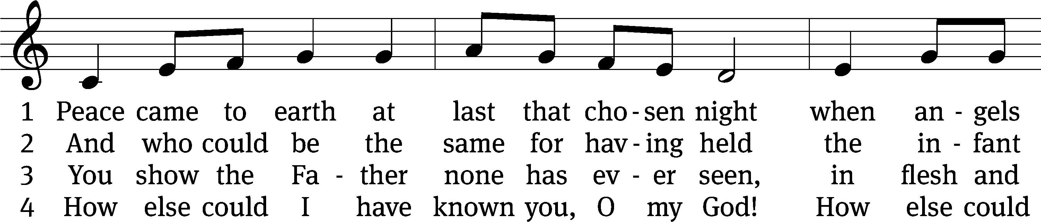
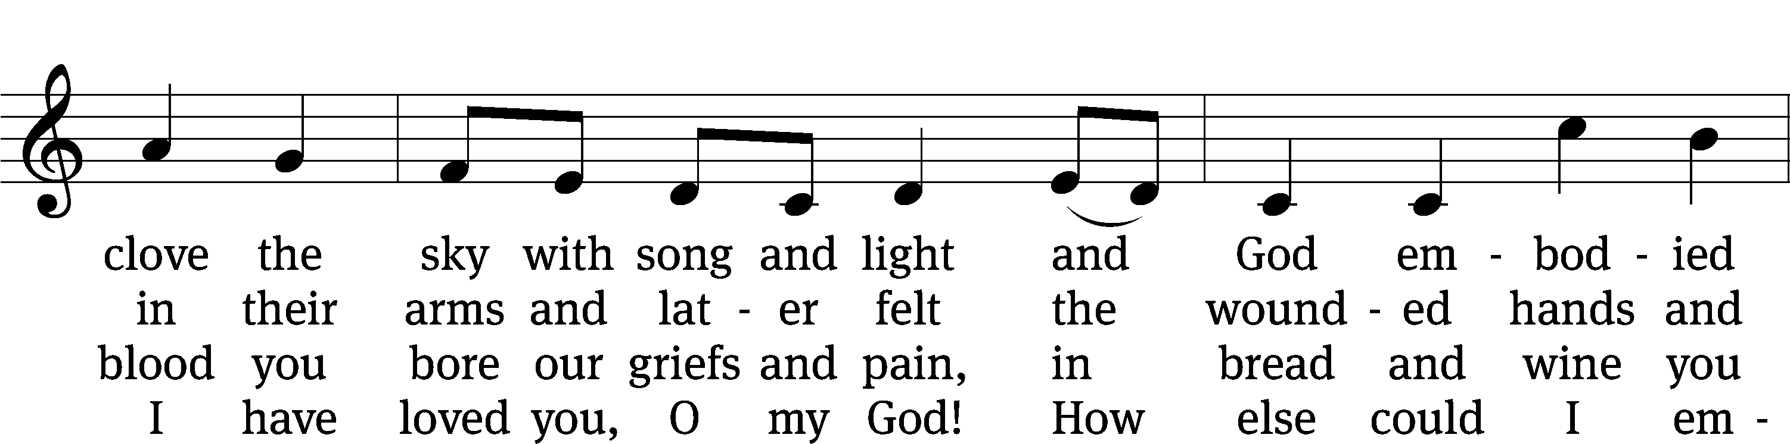
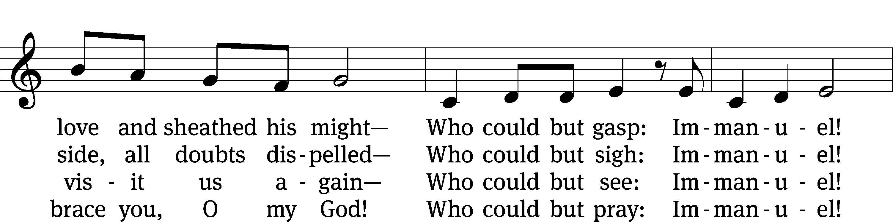
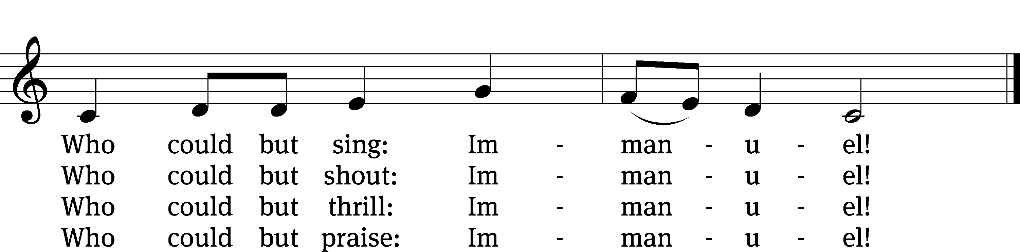
Text: Jaroslav J. Vajda, 1919–2008
Tune: Richard Jeffrey, b. 1952; arr. Mark Kellner, 1959–2015, alt.
Text: © 1984 Concordia Publishing House. Used by permission: OneLicense no. 710622
Tune: © 2000 MorningStar Music Publishers, Inc. Used by permission: OneLicense no. 710622

He Is Peace Micah 5:2–5a
2But you, Bethlehem Ephrathah,
though you are small among the clans of Judah,
from you, will go out the one who will be the ruler for me in Israel.
His goings forth are from the beginning, from the days of eternity.
3Therefore the Lord will give them up,
until the time when the woman who is in labor bears a child.
Then the remaining survivors from his brothers will return to the people of Israel.
4He will stand and shepherd with the strength of the Lord,
in the majesty of the name of the Lord his God.
They will dwell securely, for at that time he will be great to the ends of the earth.
5This one will be their peace.

The Word of the Lord.
Thanks be to God.

HYMN RESPONSE O Little Town of Bethlehem | CW 333:1,2
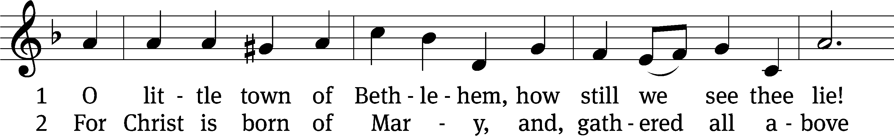
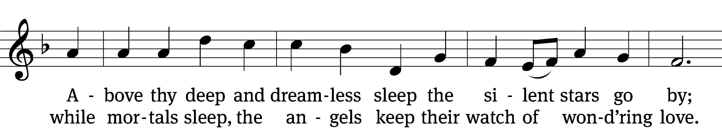
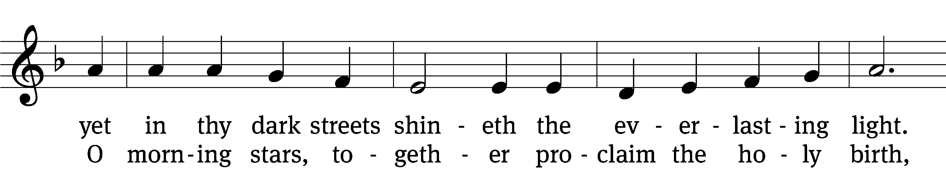
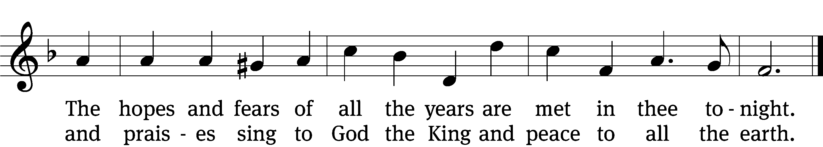
Text: Phillips Brooks, 1835–1893, abr., alt.
Tune: Lewis H. Redner, 1831–1908
Text and tune: Public domain
SERMON Micah 5:2-5a
He is Your Peace

HYMN RESPONSE O Little Town of Bethlehem | CW 333:3,4
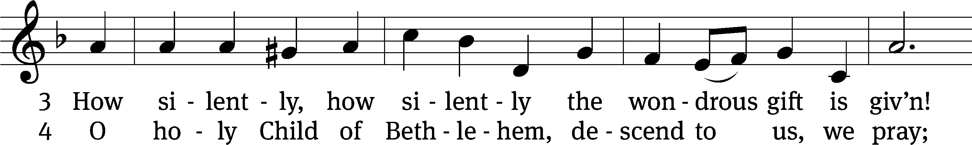
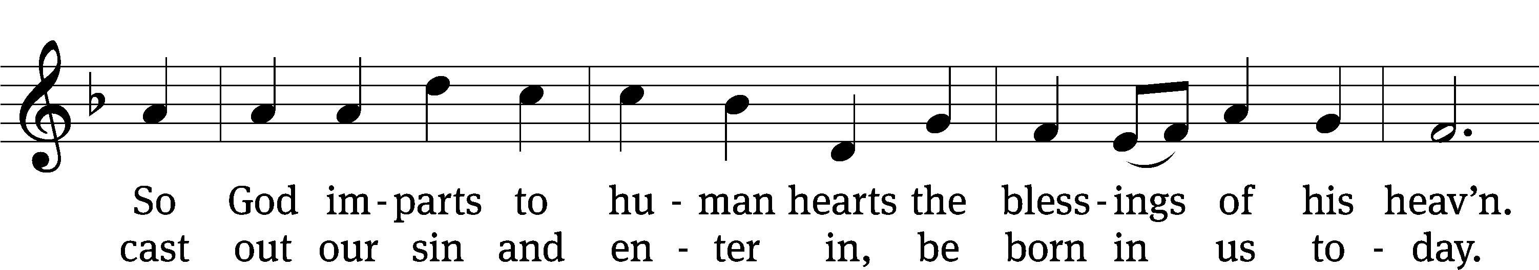
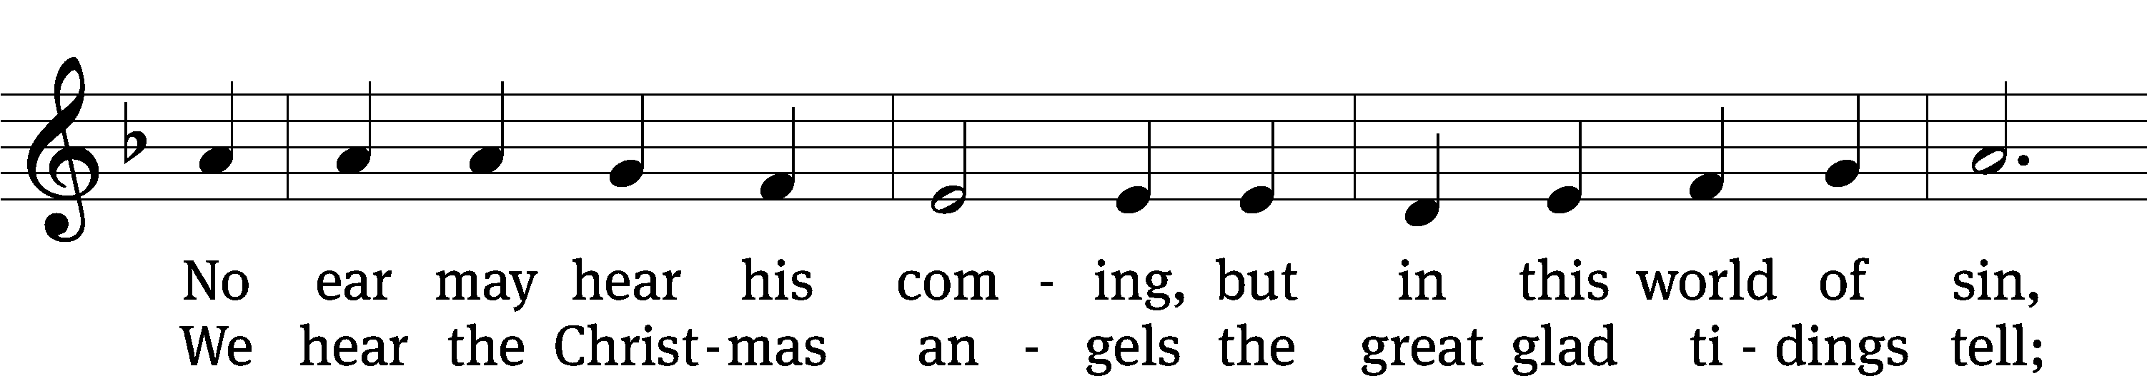
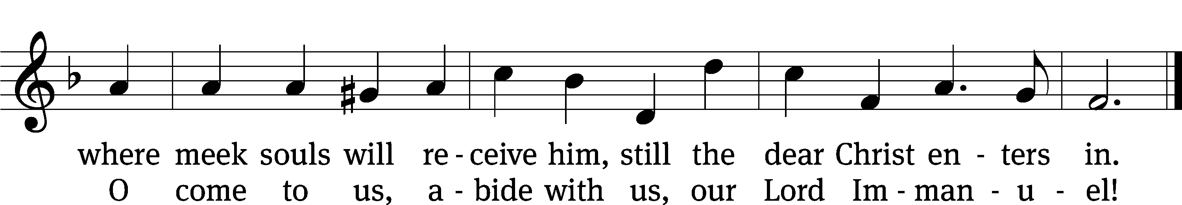
Text: Phillips Brooks, 1835–1893, abr., alt.
Tune: Lewis H. Redner, 1831–1908
Text and tune: Public domain

Grace and Peace Has Appeared Titus 2:11–14
11For the grace of God has appeared, bringing salvation to all people. 12It trains us to reject ungodliness and worldly lusts and to live self-controlled, upright, and godly lives in this present age, 13while we wait for the blessed hope, that is, the glorious appearance of our great God and Savior, Jesus Christ. 14He gave himself for us, to redeem us from all lawlessness and to purify for himself a people who are his own chosen people, eager to do good works.

The Word of the Lord.
Thanks be to God.

HYMN RESPONSE Love Has Come | CW 364
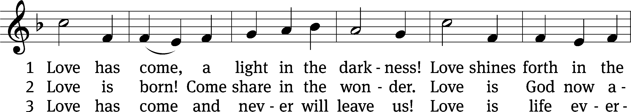
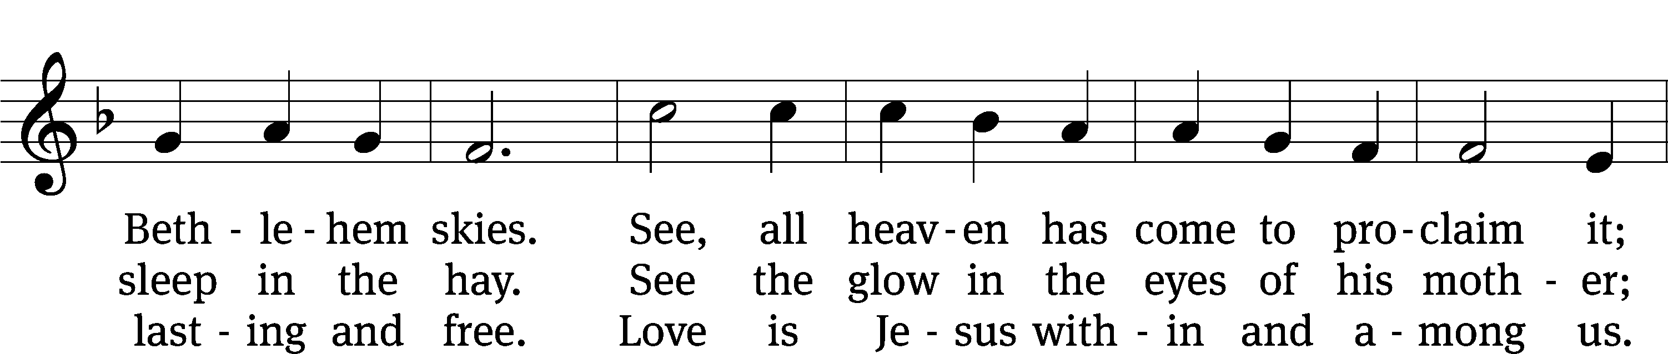
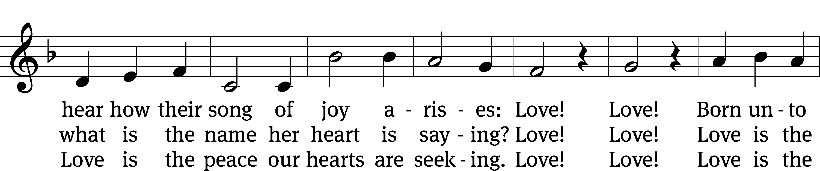
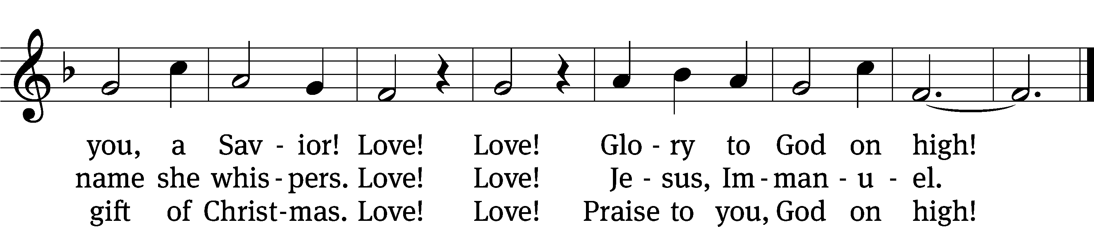
Text: Ken Bible, b. 1950
Tune: F. Seguin, Recueil de noëls composés en langue provençale, 1856
Text: © 1996 LNW Hymns, admin. Music Services, Inc. Used by permission: OneLicense no. 710622
Tune: Public domain

Please stand

Peace Born for Us Luke 2:1–7
1In those days a decree went out from Caesar Augustus that all the world should be registered. 2This was the first census taken while Quirinius was governing Syria. 3And everyone went to register, each to his own town. 4And Joseph also went up from Galilee, out of the town of Nazareth, into Judea, to the town of David, which is called Bethlehem, because he was from the house and family line of David. 5He went to be registered with Mary, his wife, who was pledged to him in marriage and was expecting a child.
6And so it was that while they were there, the time came for her to give birth. 7And she gave birth to her firstborn son, wrapped him in swaddling cloths, and laid him in a manger, because there was no room for them in the inn.

The Gospel of the Lord’s Birth.
Thanks be to God!

Please be seated

HYMN RESPONSE All My Heart Again Rejoices | CW 329
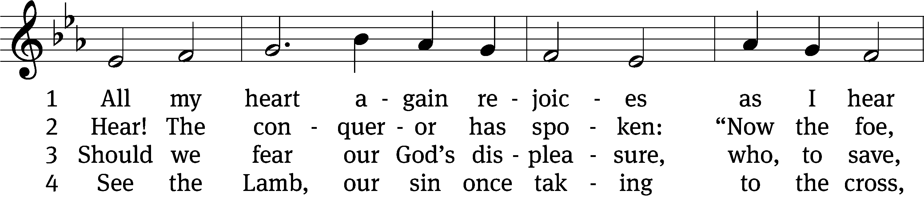
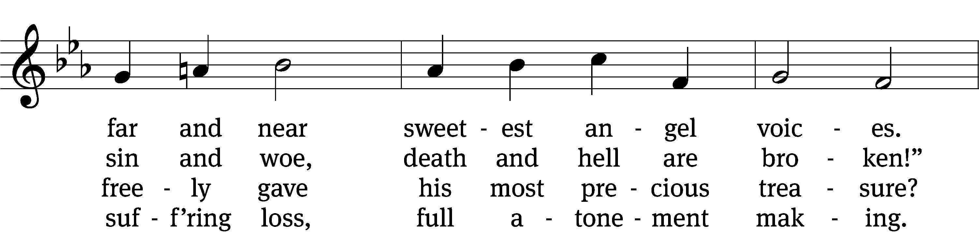
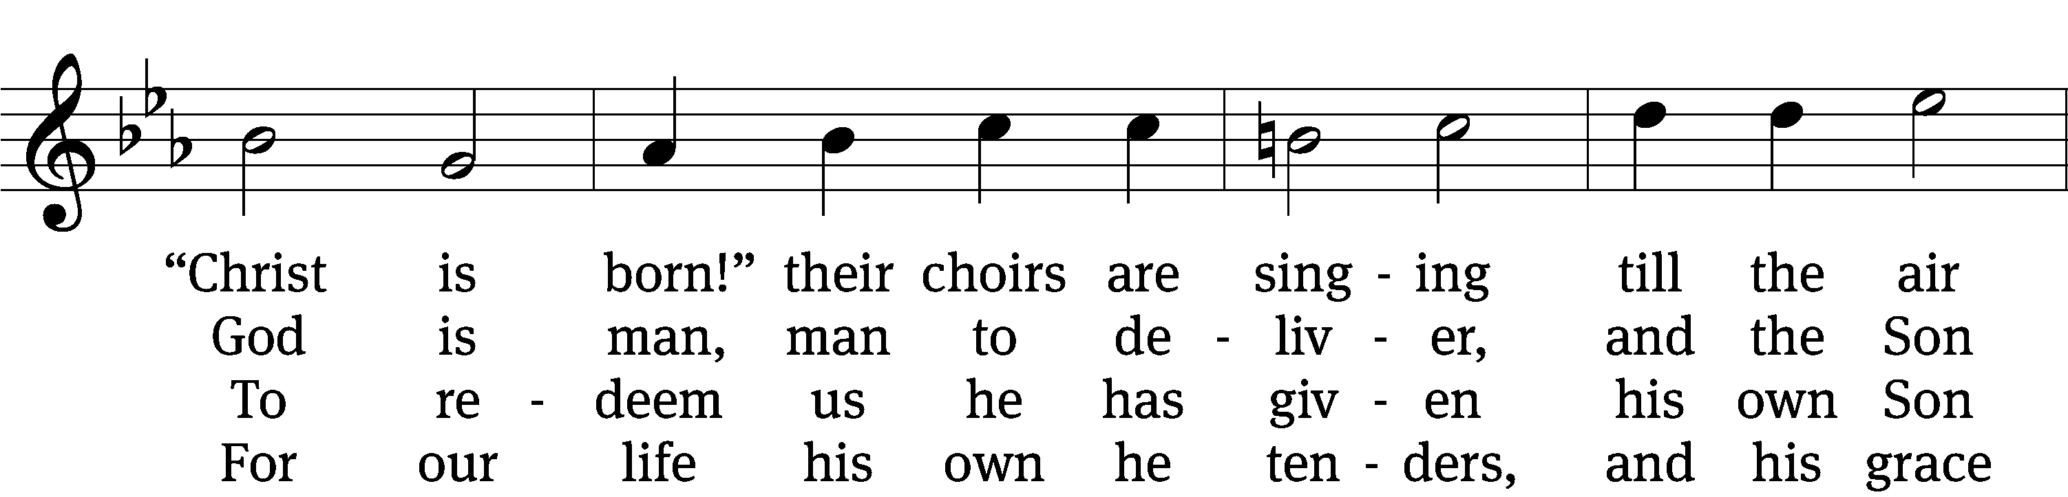
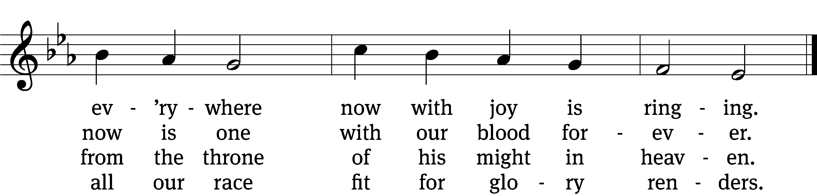

5 Softly from his lowly manger
Jesus calls
one and all,
“You are safe from danger.
Children, from the sins that grieve you
you are freed;
all you need
I will surely give you.”

6 Come, then, banish all your sadness!
One and all,
great and small,
come with songs of gladness;
we shall live with him forever
there on high
in that joy
which will vanish never.

Text: Paul Gerhardt, 1607–1676, abr., adapt.; tr. Catherine Winkworth, 1827–1878, alt.
Tune: Johann Crüger, 1598–1662
Text and tune: Public domain

Peace Proclaimed Luke 2:8–14
8There were in the same country shepherds staying out in the fields, keeping watch over their flock at night. 9An angel of the Lord appeared to them, and the glory of the Lord shone around them, and they were terrified! 10But the angel said to them, “Do not be afraid. For behold, I bring you good news of great joy, which will be for all people: 11Today in the town of David, a Savior was born for you. He is Christ the Lord. 12And this will be a sign for you: You will find a baby wrapped in swaddling cloths and lying in a manger.” 13Suddenly, there was with the angel a multitude from the heavenly army, praising God and saying, 14“Glory to God in the highest, and on earth peace, good will toward mankind.”

The Word of the Lord.
Thanks be to God.

HYMN RESPONSE Angels We Have Heard on High | CW 346:1,3
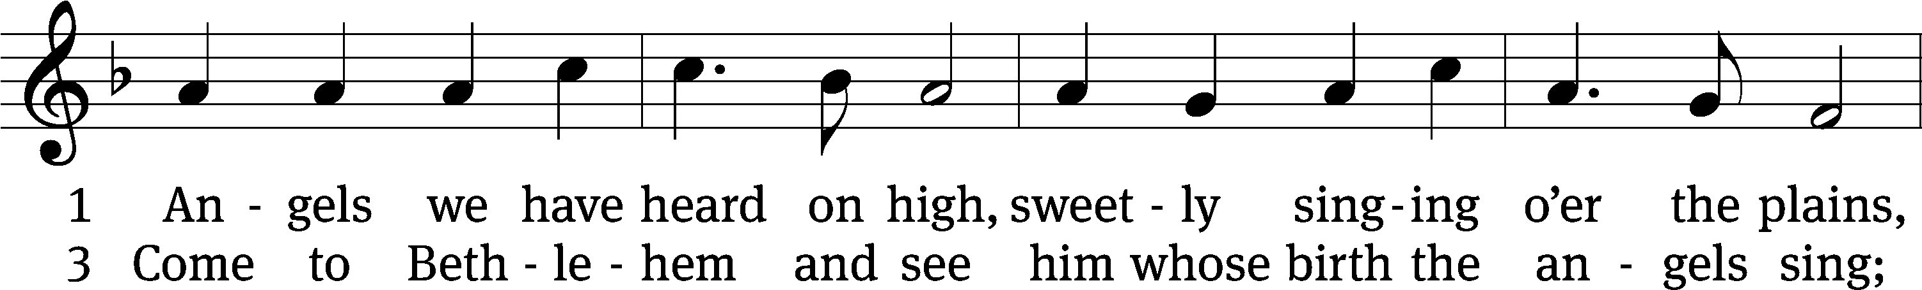
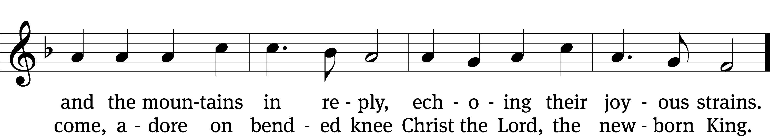
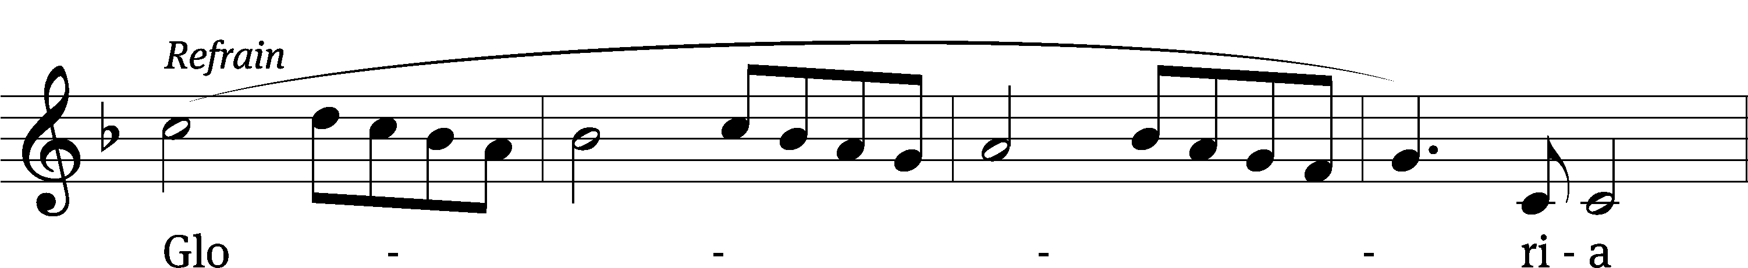
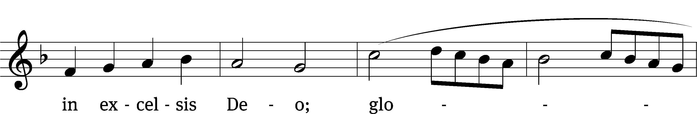
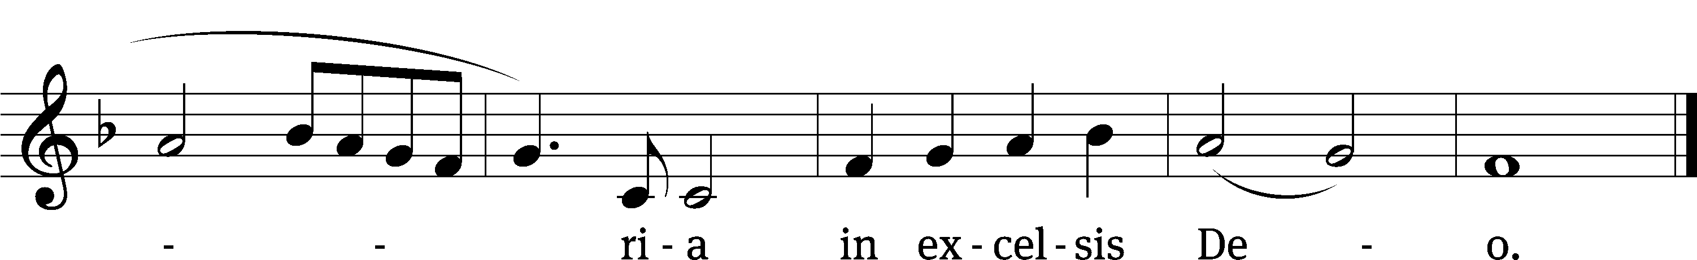
Text: French; tr. The Crown of Jesus, Part 2, 1862, alt.
Tune: French
Text and tune: Public domain

Peace to Treasure Luke 2:15–20
15When the angels went away from them into heaven, the shepherds said to one another, “Now let's go to Bethlehem and see this thing that has happened, which the Lord has made known to us.” 16So they hurried off and found Mary and Joseph, and the baby, who was lying in the manger. 17When they had seen him, they told others the message they had been told about this child. 18And all who heard it were amazed by what the shepherds said to them. 19But Mary treasured up all these things, pondering them in her heart. 20And the shepherds returned, glorifying and praising God for all the things that they had heard and seen, which were just as they had been told.

The Word of the Lord.
Thanks be to God.
HYMN RESPONSE Once in Royal David’s City | CW 343
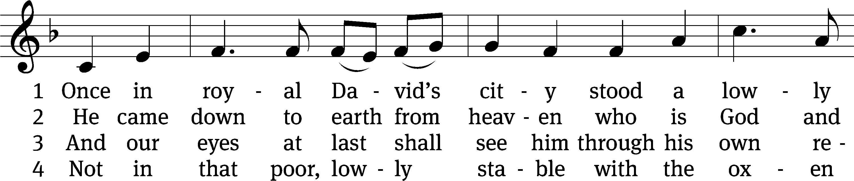
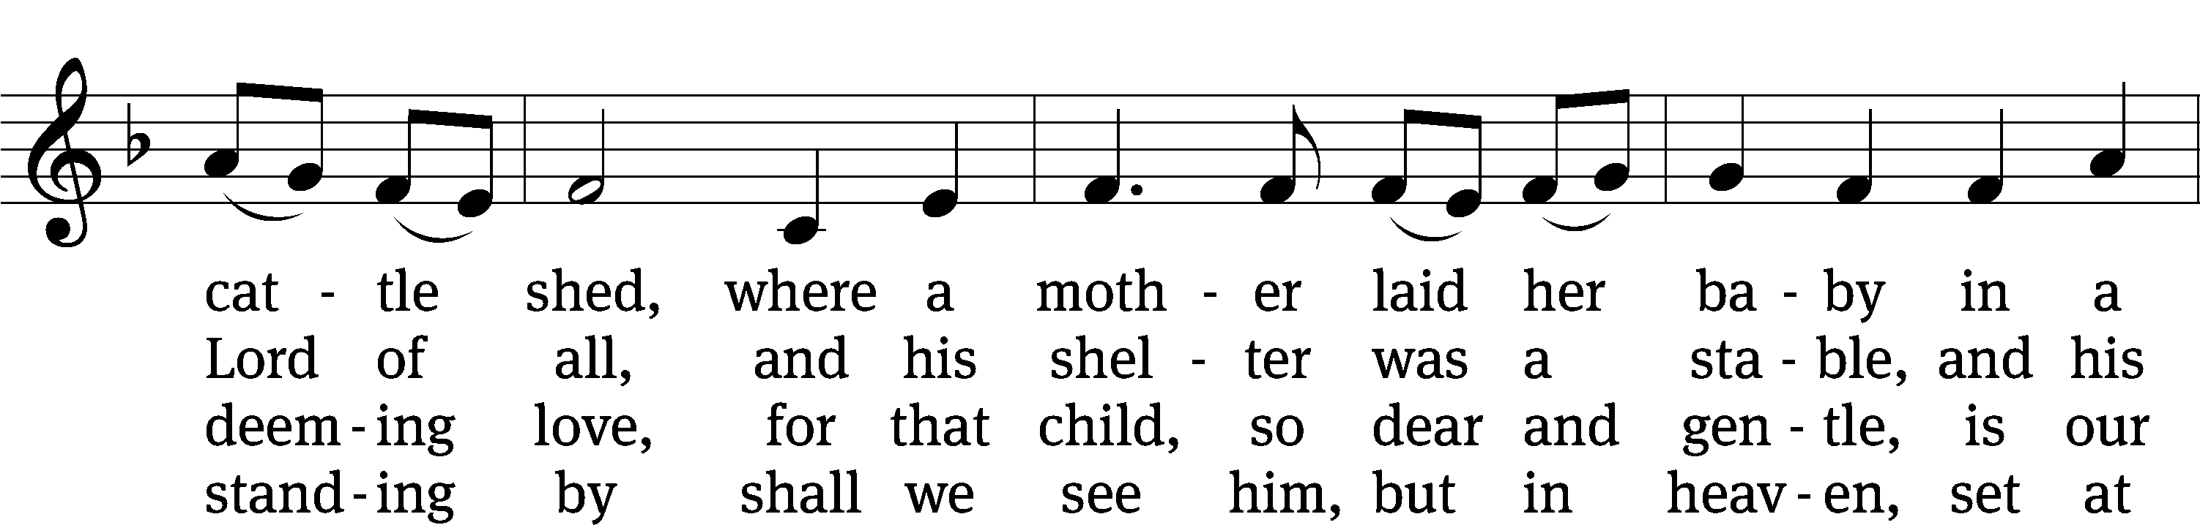
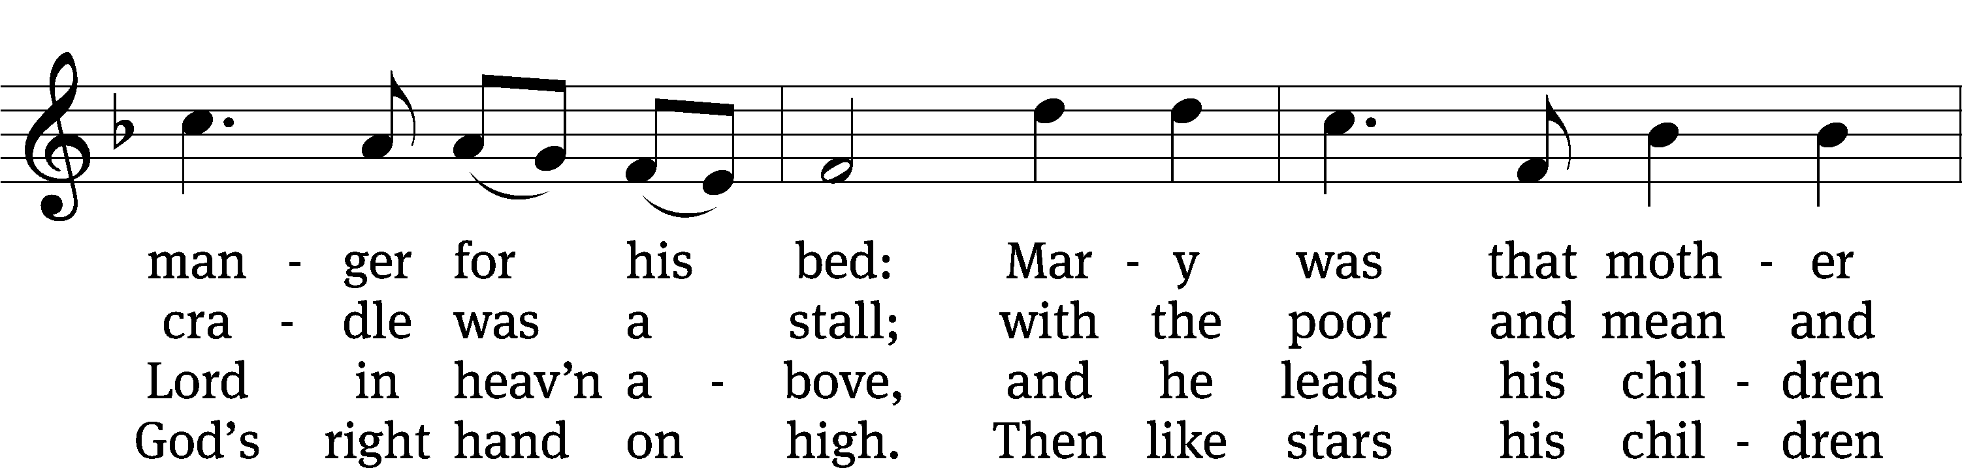
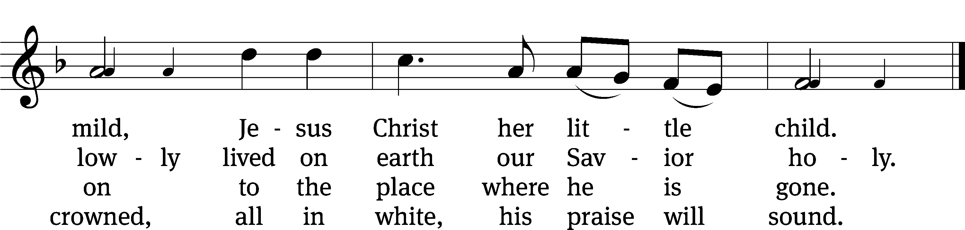
Text: Cecil F. Alexander, 1818–1895, abr., alt.
Tune: Henry J. Gauntlett, 1805–1876
Text and tune: Public domain

Please stand

Litany of the nativity
God, loving Father, you sent your one and only Son,
have mercy.
Jesus Christ, you are the Word who became flesh to save the world,
have mercy.
Holy Spirit, you connect us to the love and power of God with your Word,
have mercy.

Holy Trinity,
splendor and majesty are yours.

Jesus,
promised Seed of the woman,
Bringer of peace,
Immanuel,
Wonderful Counselor,
Mighty God,
Everlasting Father,
Prince of Peace,
have mercy on us.

Jesus,
because you were conceived by the Holy Spirit,
because you were born of the virgin Mary,
because you became flesh and made your dwelling among us,
because you became truly human, like us in every way, except without sin,
because you endured every hardship common to humanity,
because you suffered under Pontius Pilate,
because you were crucified,
because you suffered death as the wages of the world’s sin,
because you were buried,
hear our prayer.

Jesus,
because you broke the gates of hell,
because you rose in glory,
because you ascended on high,
because you intercede for us at your Father’s right hand,
hear our prayer.

Jesus, Son of God,
have mercy on us.
Jesus, Son of Mary,
have mercy on us.
To us a child is born.
To us a Son is given.

Lord Jesus Christ, Word of the Father, now in flesh appearing, give us your blessed hope as we hear again of your first coming. Fill our lives with the glory of your love, and empower us to live to your glory, for you are God’s gift of love, once wrapped in swaddling clothes, now wrapped in the pages of Scripture, no longer in a cattle stall or feeding trough, but living and reigning with your Father and the Holy Spirit, one God, dwelling in the highest glory, granting peace to your people, now and forever.
Amen.

LORD’S PRAYER Sung to the tune of “Away in a Manger” | CW 340
Our Father in heaven, all praise to your name!
Your kingdom among us, your will done the same
By mortals and angels. Come, Lord, reign alone;
Oh, hear us and bless us from heaven’s high throne.

The bread that we yearn for provide us each day;
As we forgive others, our sins take away;
In times of temptation, to lead us be near;
From evil deliver your children most dear.

For yours is the kingdom; o’er all things you reign.
And yours is the power; all things you maintain.
To you be the glory, resounding again
From all of creation, forever! Amen.
Blessing
M: The Lord bless you and keep you.
The Lord make his face shine on you and be gracious to you.
The Lord look on you with favor and (+) give you peace.
C: Amen.

Please be seated

CLOSING HYMN Silent Night, Holy Night | CW 337
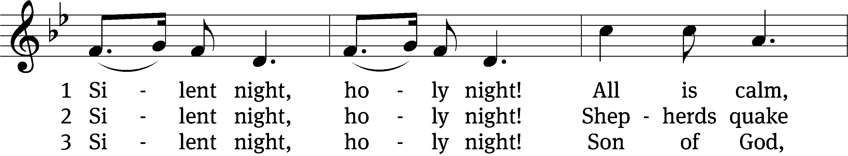
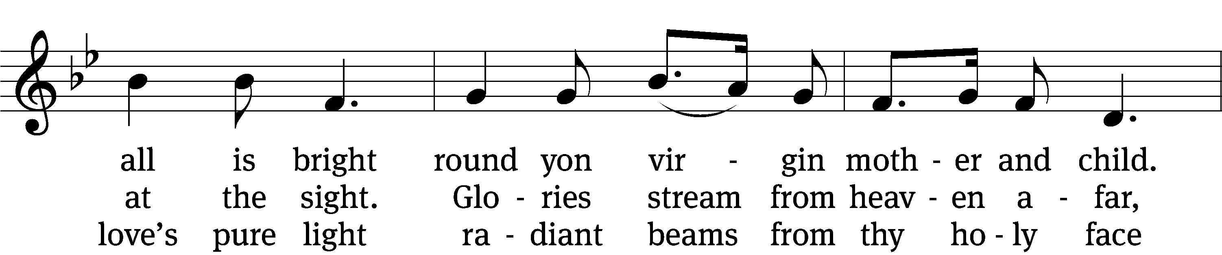
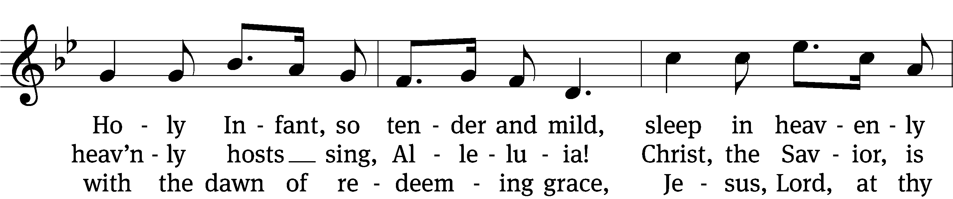
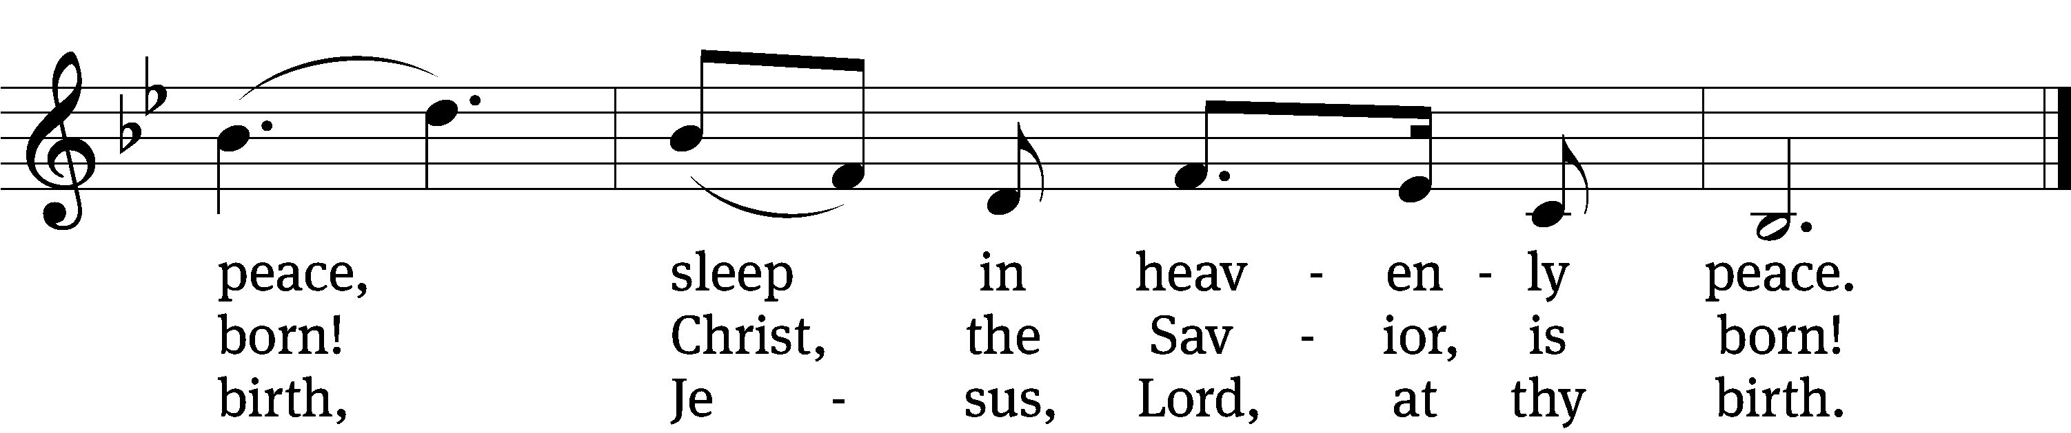
Text: Franz Joseph Mohr, 1792–1848; tr. John F. Young, 1820–1885
Tune: Franz Xaver Gruber, 1787–1863
Text and tune: Public domain

WANT TO LEARN MORE? upcoming BIBLE BASICS classes

Want to understand the message of the Bible better?
Gives a foundational understanding of Bible teaching at Peace Lutheran
School & Early Childhood Center

Great review for long time Christians
Serves as entrance course toward Peace membership.
No obligation or cost.
3 different courses, each teaching the same Scriptural content:
The Foundation of our Faith – led by Pastor Werre
Christ the Life of all the Living – led by Pastor Arndt
Growing in Hope – led by Pastor Ertl
Each course is 1 class per week for 1.5-2 hours for 8-10 weeks.

Thursdays beginning January 15, 6:30-8:00 p.m.
The Foundation of our Faith
Please register luke.werre@peacewels.org or (608) 837-5346

Tuesdays beginning January 27 - 6:30–8:30 p.m.
Christ the Life of all the Living
Please register shaun.arndt@peacewels.org or (608) 837-5346

Growing in Hope
Are you interested in a Bible Basics class, but the above times do not work for you? Pastor Ertl is looking to build a class around a time that will fit your schedule.
Please contact him: jordan.ertl@peacewels.org or (608) 837-5346

ACKNOWLEDGMENTS
Unless otherwise noted, Scripture quotations are from the Holy Bible, Evangelical Heritage Version® (EHV®) © 2017 Wartburg Project. All rights reserved. Used by permission.
Liturgical and musical settings of Scripture based on text from The Holy Bible, New International Version®, NIV®. Copyright © 1973, 1978, 1984, 2011 by Biblica, Inc.TM Used by permission of Zondervan. All rights reserved worldwide.
Software distributed in partnership with Northwestern Publishing House.
Created by Christian Worship: Service Builder © 2025 Concordia Publishing House.

Each Sunday in Advent, the successive blue candles were lit while we sang the ancient carol: O Come, O Come Emmanuel. Tonight we sing the good news that the Son of God became truly human and came into the world as Immanuel to save us. (Immanuel is a Hebrew Title for the Savior which means: “God with Us.”)

